MYSQL TASK 1

1. SQL Lesson 1: SELECT queries 101

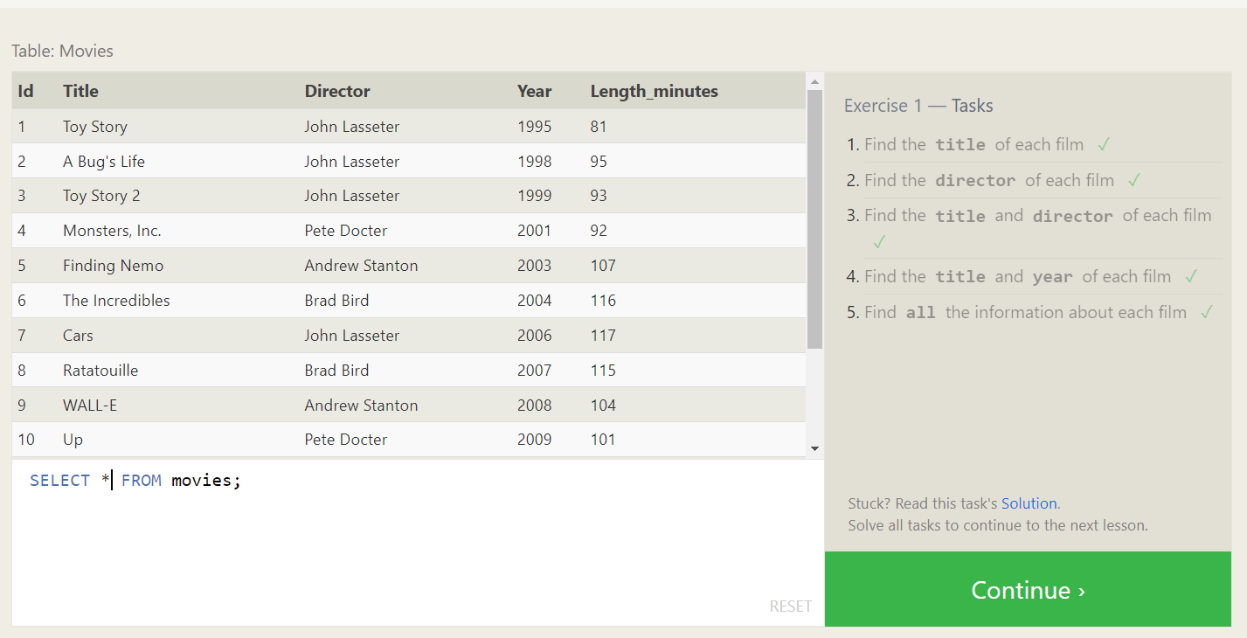

1. SQL Lesson 2: Queries with constraints (Pt. 1)

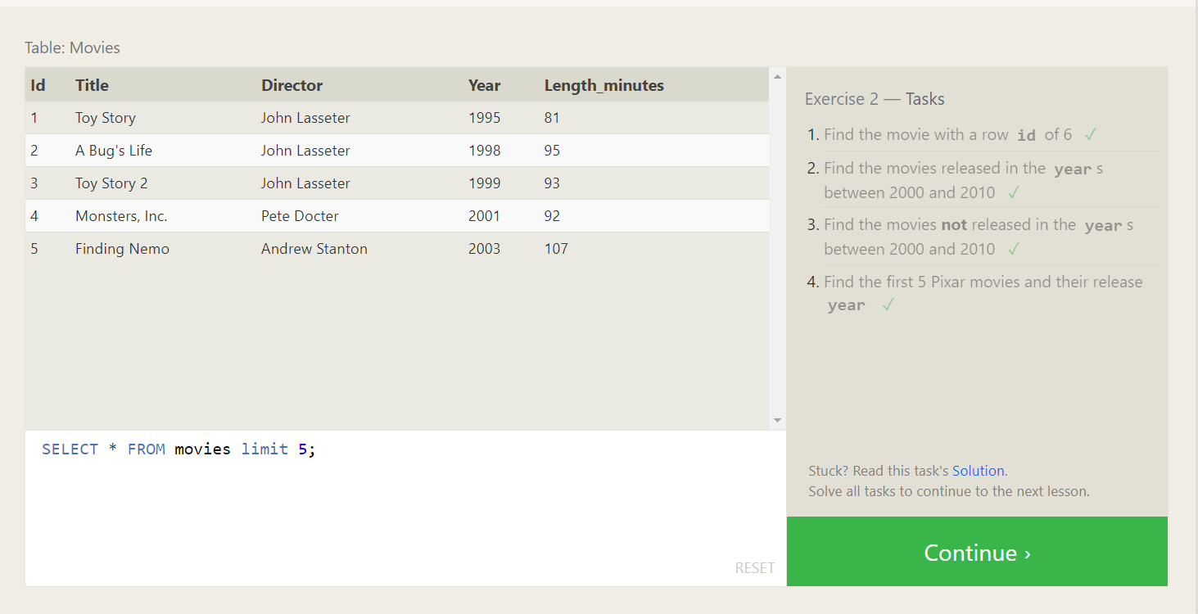

1. SQL Lesson 3: Queries with constraints (Pt. 2)

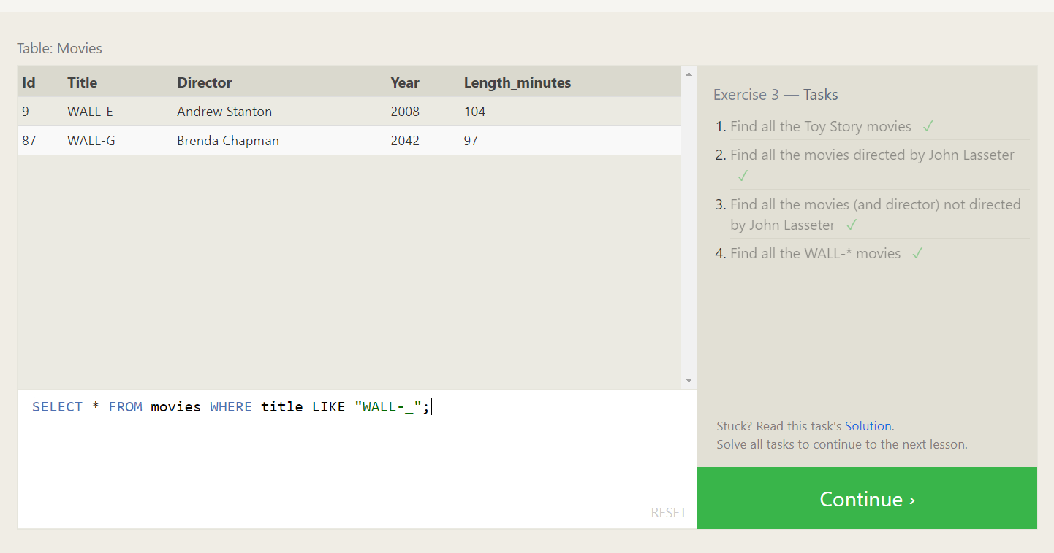

1. SQL Lesson 4: Filtering and sorting Query results

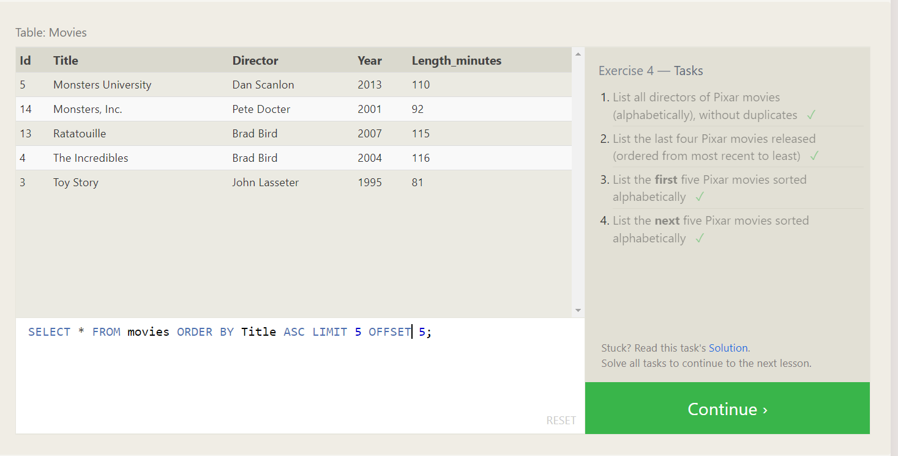

1. SQL Review: Simple SELECT Queries

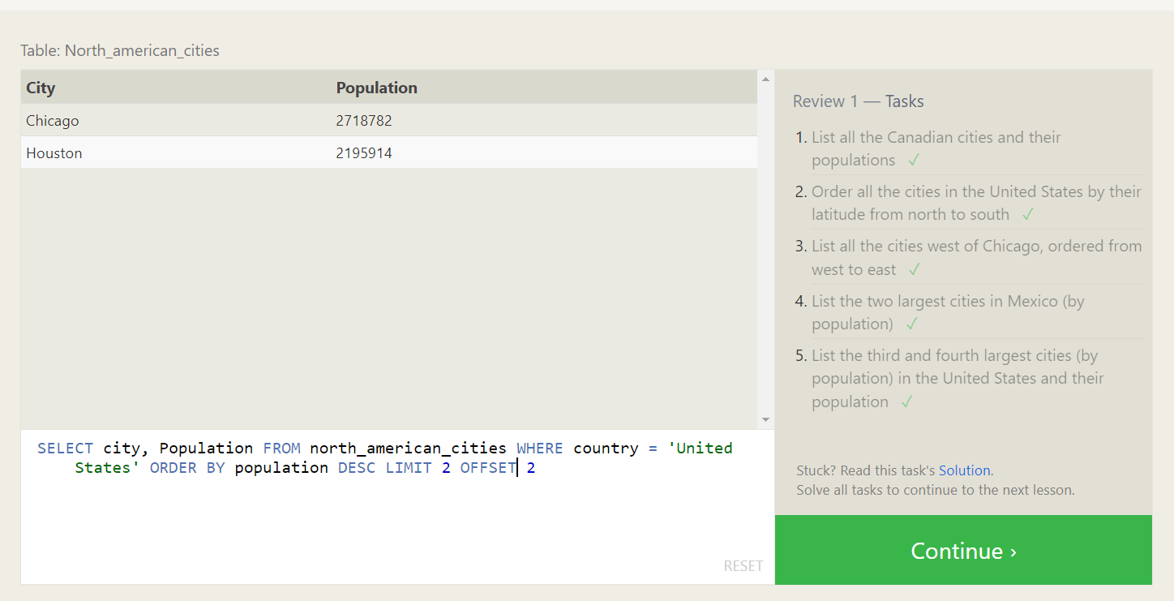

1. SQL Lesson 6: Multi-table queries with JOINs

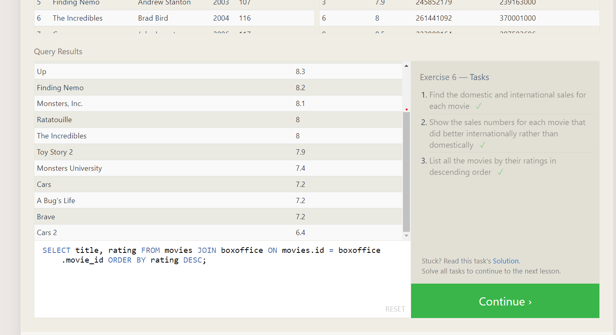

1. SQL Lesson 7: OUTER JOINs

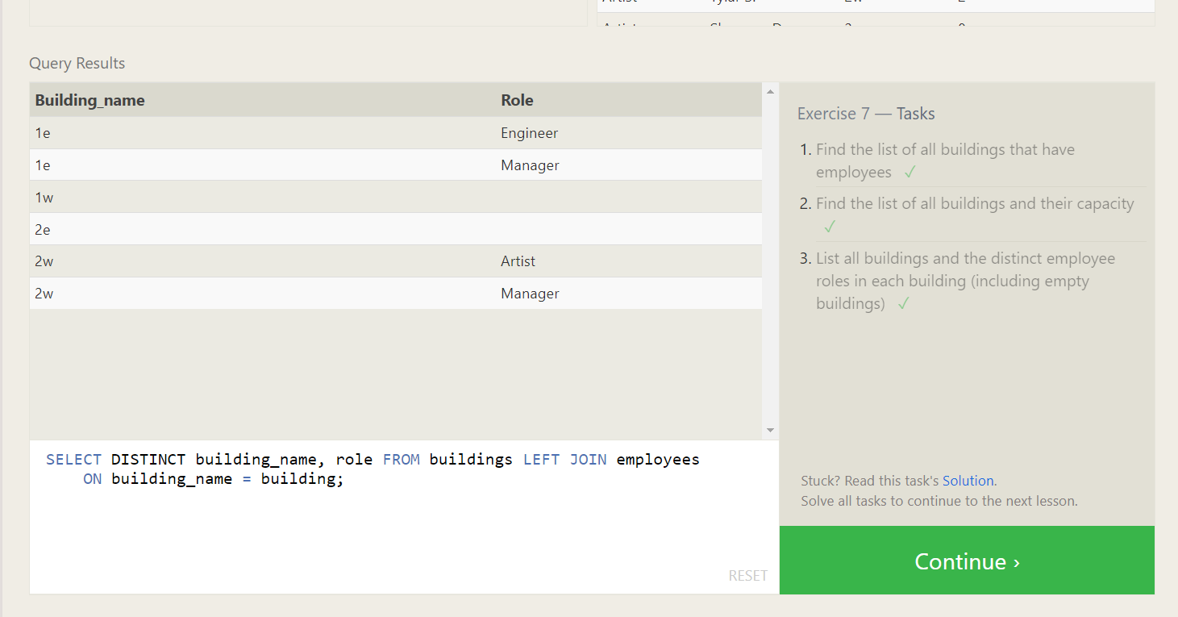

1. SQL Lesson 8: A short note on NULLs

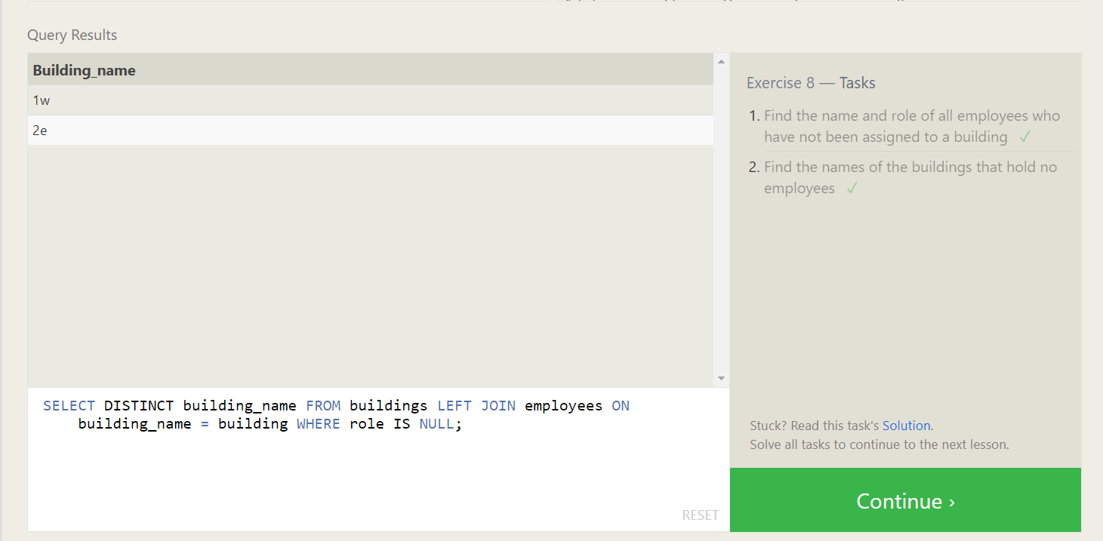

1. SQL Lesson 9: Queries with expressions

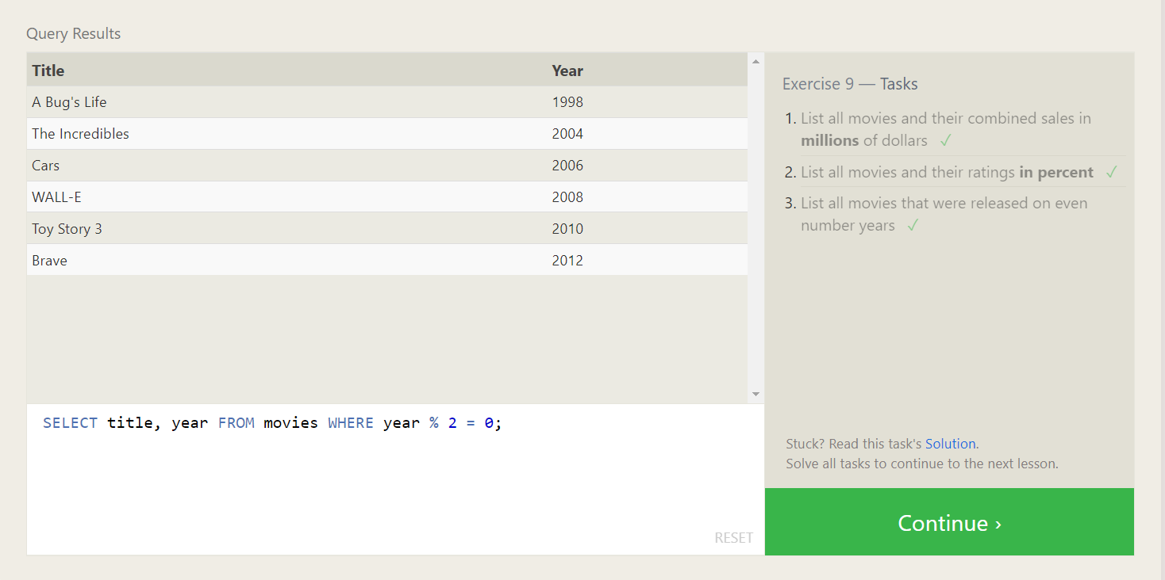

1. SQL Lesson 10: Queries with aggregates (Pt. 1)

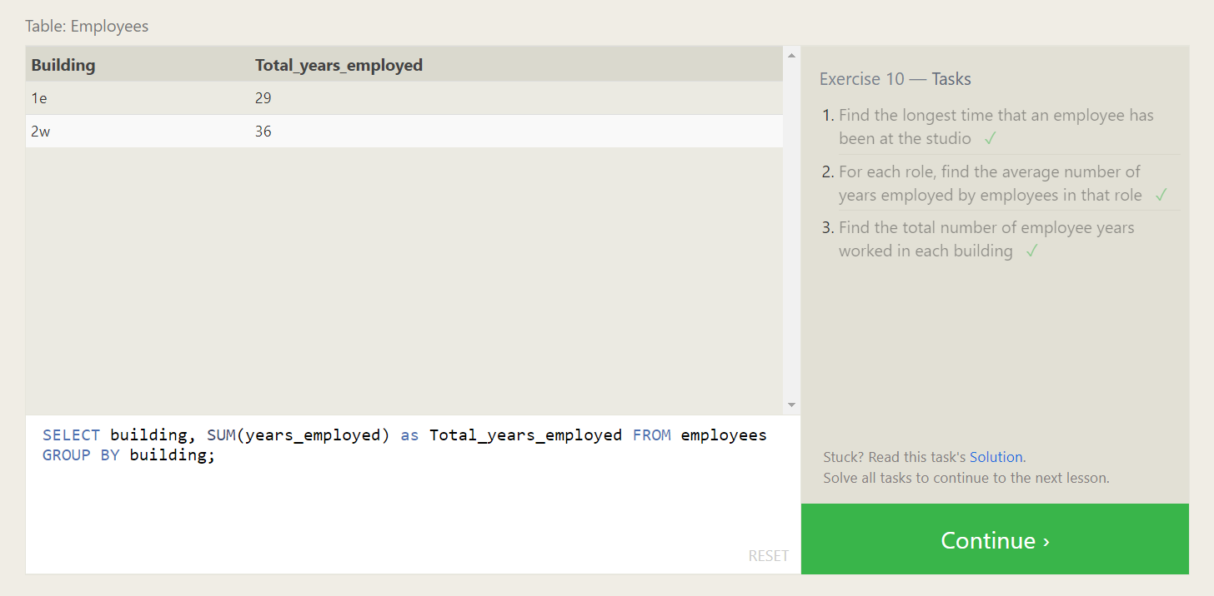

1. SQL Lesson 11: Queries with aggregates (Pt. 2)

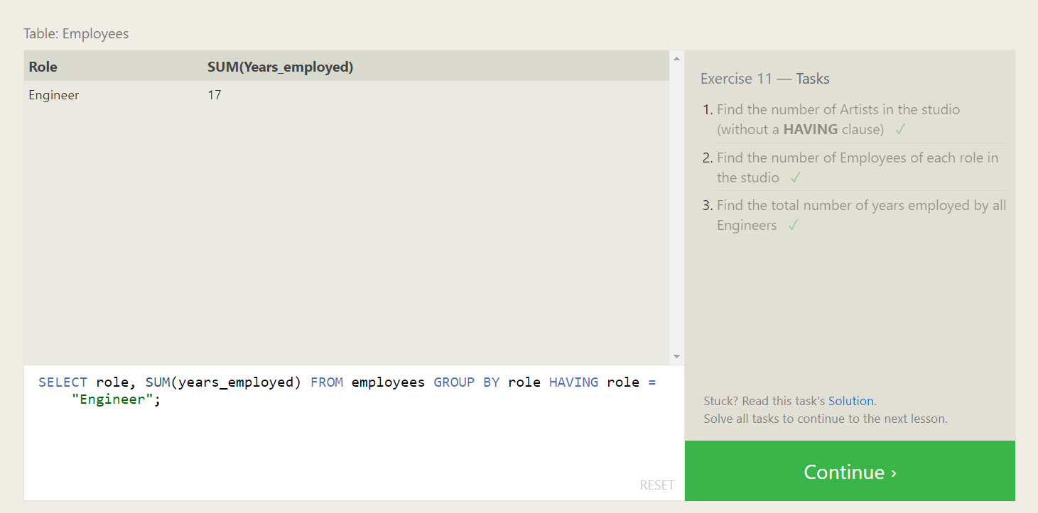

1. SQL Lesson 12: Order of execution of a Query

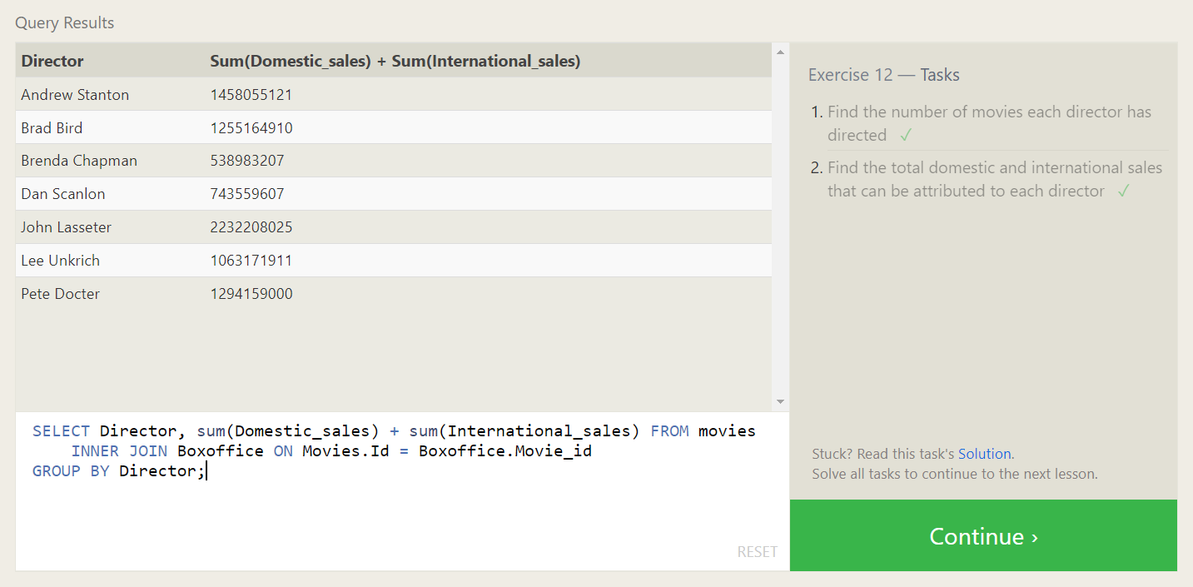

1. SQL Lesson 13: Inserting rows

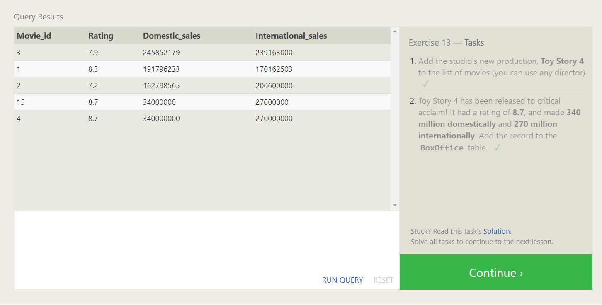

1. SQL Lesson 14: Updating rows

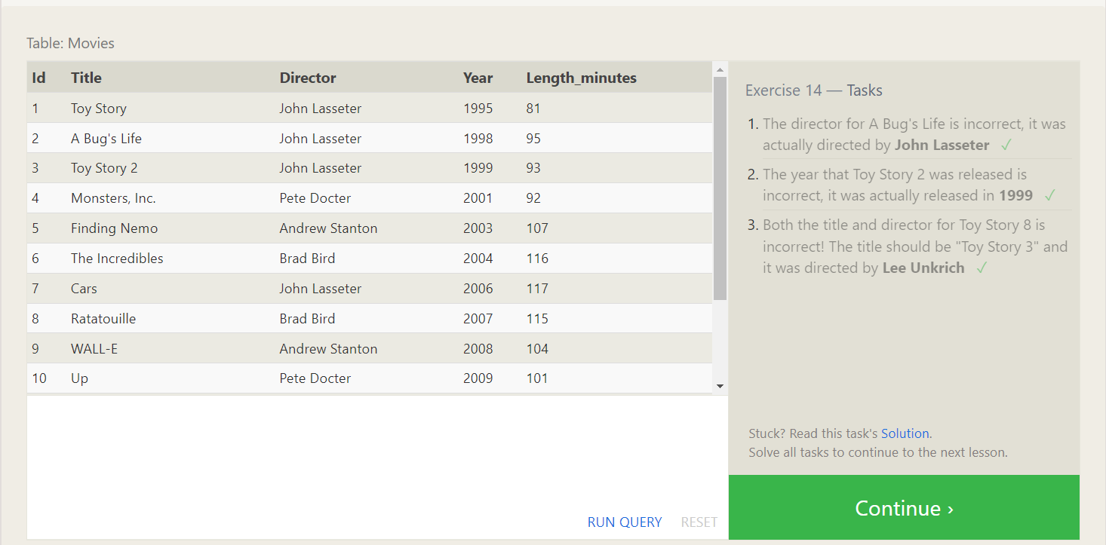

1. SQL Lesson 15: Deleting rows

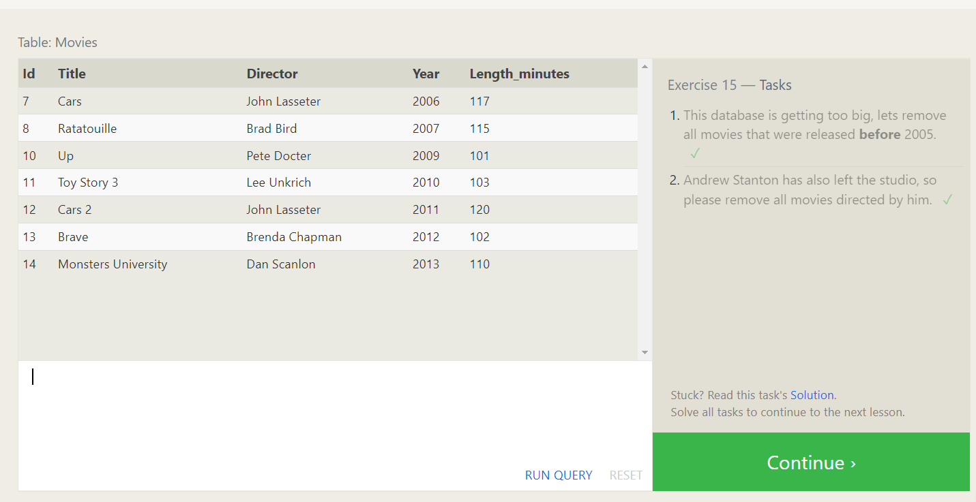

1. SQL Lesson 16: Creating tables

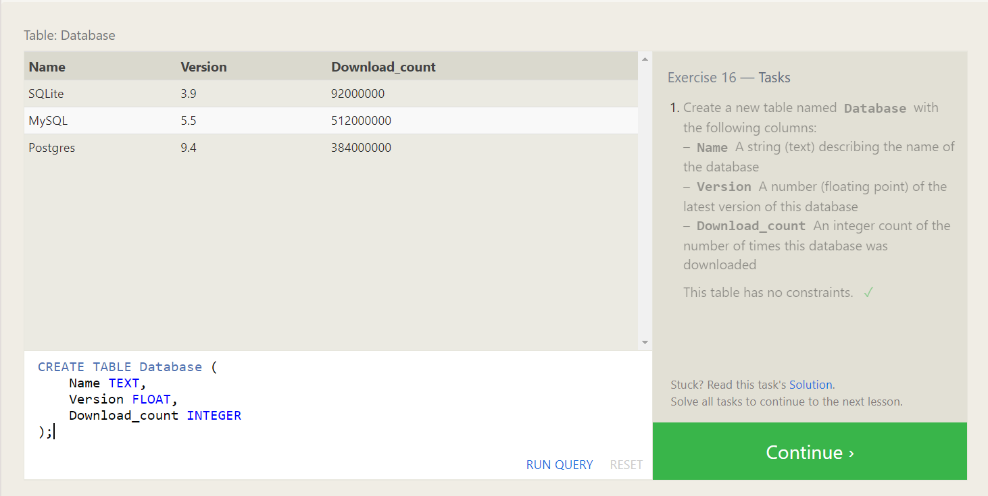

1. SQL Lesson 17: Altering tables

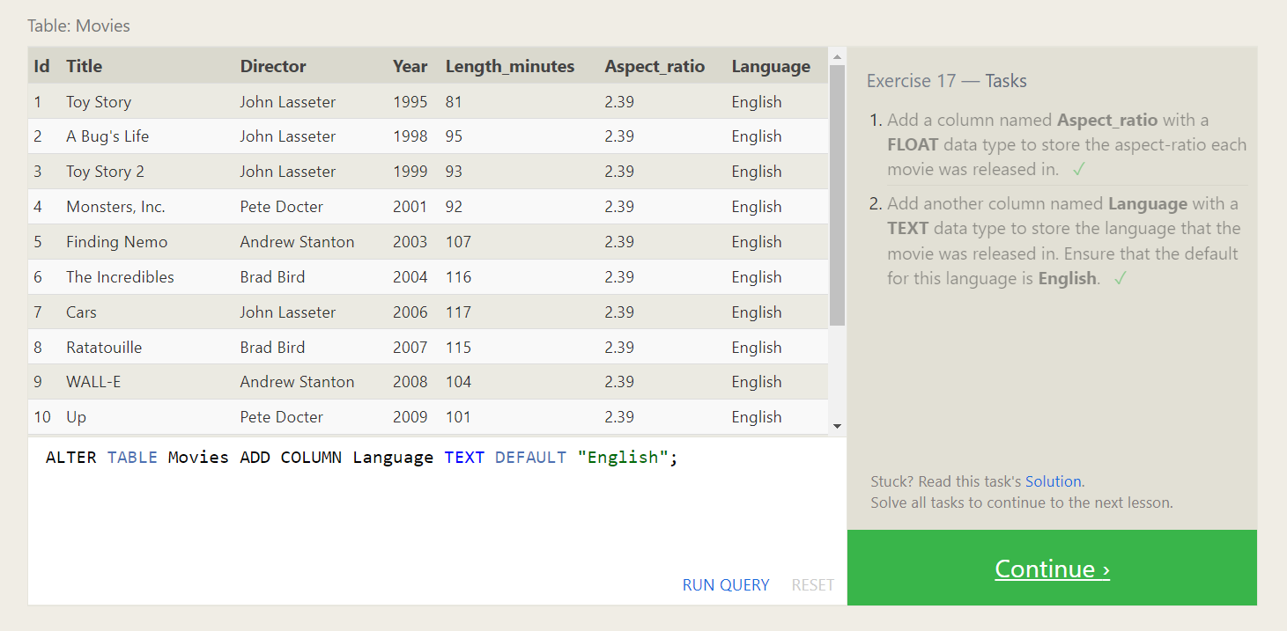

1. SQL Lesson 18: Dropping tables

